**ONLINE MOBILE RECHARGE SYSTEM**

**ASP.Net Web API** **Project**

**[ASP.NET – MVC - WEB API / AJAX / JQUERY/ ENTITY FRAMEWORK /**

**SQL SERVER]**

**Submitted By:**

**Naveeth Z A**

**Rajagurunathan Manikandan**

**Saravanakumar Balasubramaniyam**



October - 2020

**PROJECT DESCRIPTION**

**Project Title :** Online Mobile Recharge System

**Abstract :** This System provides recharge of many mobile companies as well as all kind of recharge are possible. This System will provide facility for customer to recharge mobile at anytime from anywhere. This System keeps the history of the past recharges. The user has to register himself.

**Type of Project:** Web API Application

**Technology :** ASP.Net – Web API -MVC, JQuery, AJAX, Entity Framework

**Database :** SQL-Server

**Web Application Name**:

**RPAY**

***A Payments App built for India, by Indians***

**DESCRIPTION:**

The proposed project for recharging mobiles online is a web application developed to automate the mobile recharging process. It roots out the manual card system of recharge and introduces a new and genuine online recharge process. It can be used by costumer of any telecommunication company from anywhere.

The online mobile recharge system is beneficial to both the admins and users. Using the online application, the admin can add new tariff plans and update or modify the existing tariff plans. It helps the users in creating their account, and then recharging the mobiles phones at any time.

**OBJECTIVE:**

Online Mobile Recharge is a web-based application developed in ASP.NET to recharge mobile phones. The project focuses at providing an easy and reliable platform to recharge mobile of any telecommunication company through online without buying recharge card. The registered users of the system can recharge their prepaid mobile phones from anywhere at any time. The proposed project for recharging mobiles developed to automate the mobile recharging process. It roots out the manual card system of recharge and introduces a new and genuine online recharge process. The online mobile recharge system is beneficial to both the admins and users. Using the online application, the admin can add new operators, tariff plans, offers and update or modify the existing tariff plans. It helps the users in creating their account, and then recharging the mobiles phones at any time.

**PROJECT DEMO:**

**Type of Users:**

1. User / Customer
2. Admin

**Project Flow:**

* **User Functionalities:**

1. Create Account: Enter Personal & Mobile Network Details
2. Login: Authentication
3. User Home: Users can view recharge plans and various network operator details.
4. Recharge: Users can view recharge plans and recharge based on network operator and plan type using email authentication and payment gateway.
5. Add Money to Wallet: Users can add money to their wallet using credit / debit card with email authentication.
6. My Plans: Users can view their current plan and previous plans transaction history.
7. Edit Profile: User can update their personal and mobile network details. It also contains reset password option.
8. Customer Support: Users can send their queries to the respective team through mail.
9. Logout: Logout from the application

* **Admin Functionalities:**

1. Login: Authentication
2. Dashboard (Home): Admin can view the user data in different visualization format such as pie chart, bar graph and generate reports in pdf format based on the recharge plan transaction details.
3. Network Operator Manager: Admin can add, view, update, delete the network operator details.
4. Recharge Plan Manager: Admin can add, view, update, delete and search the mobile network plan details based on the network operators.
5. Plan Transaction Manager: Admin can view, search based on the transaction status and generate transaction report in the pdf format based on the transaction details.

1. Logout: Logout from the application

**DATABASE DESIGN**

**Entity Relationship Diagram:**

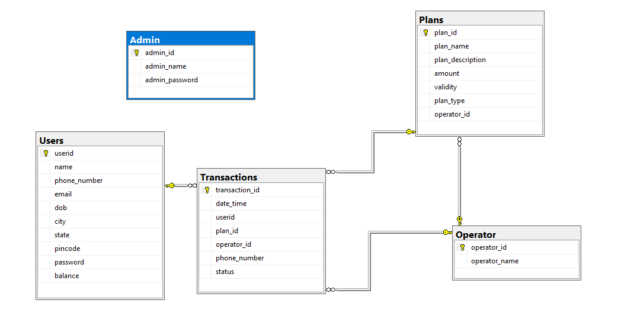

**Table Schema Diagram:**

**TABLE 1: Users**

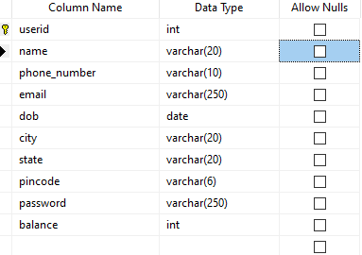

**TABLE 2: Admin**

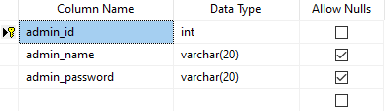

**TABLE3: Operators**

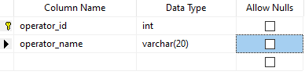

**TABLE4: Plans**

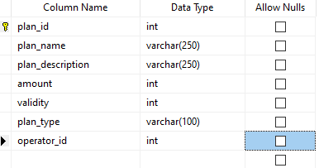

**TABLE5: Transactions**

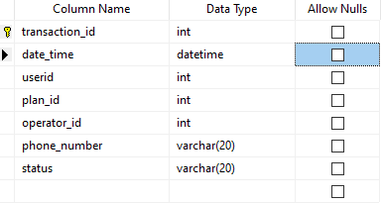

**SOURCE CODE**

**User Login**

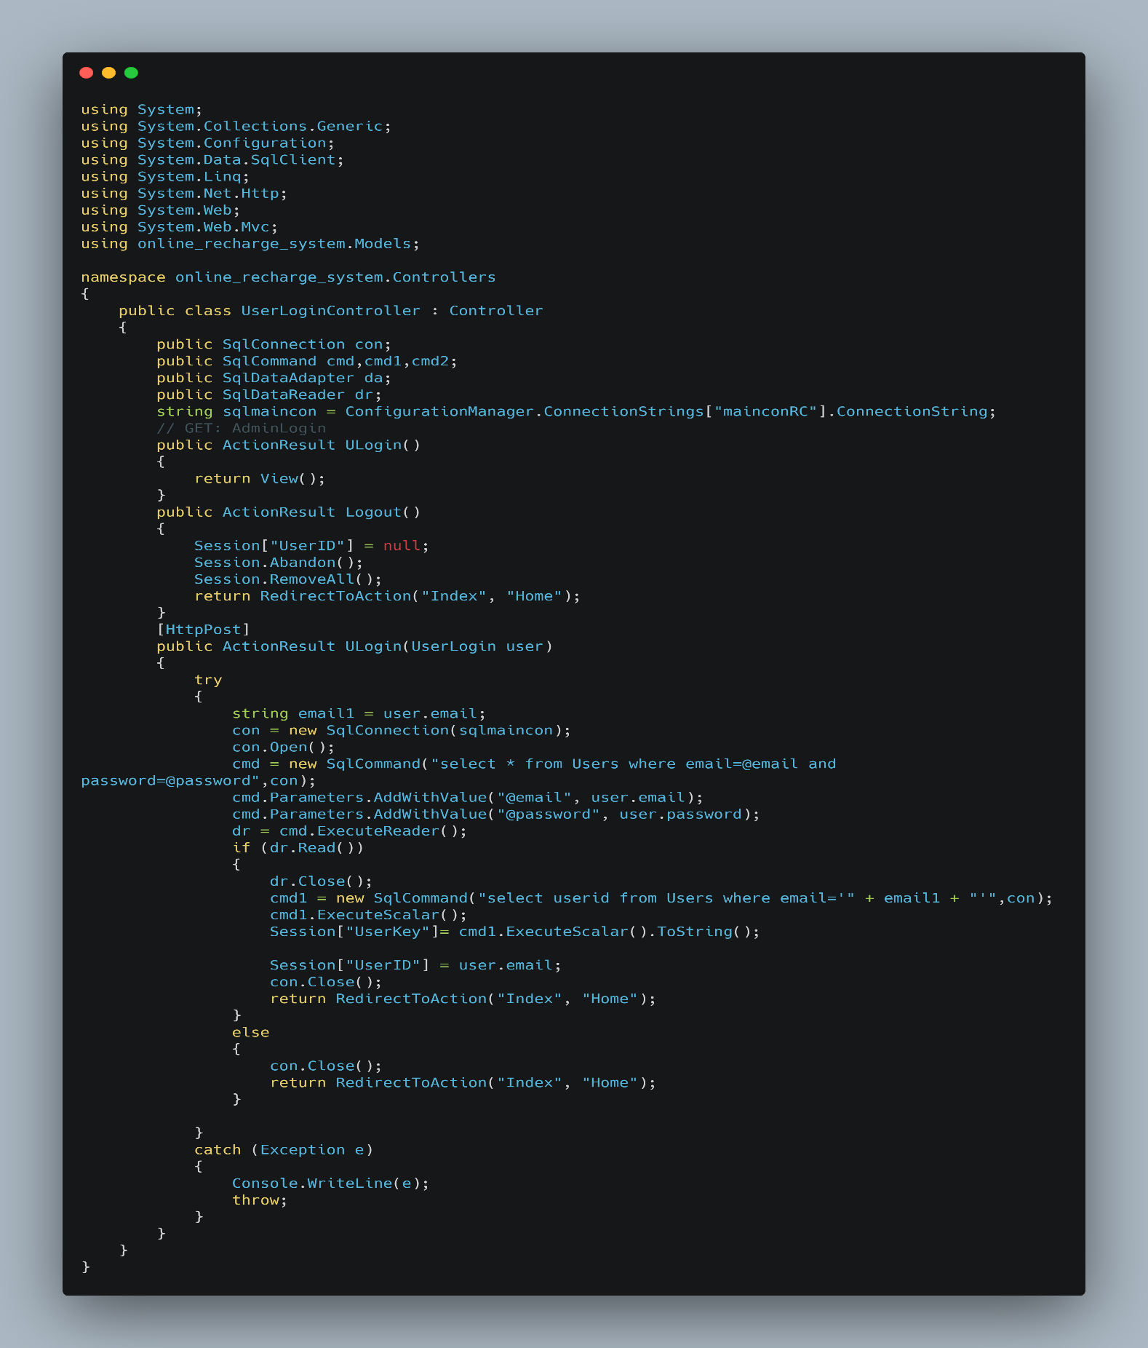

**Recharge:**

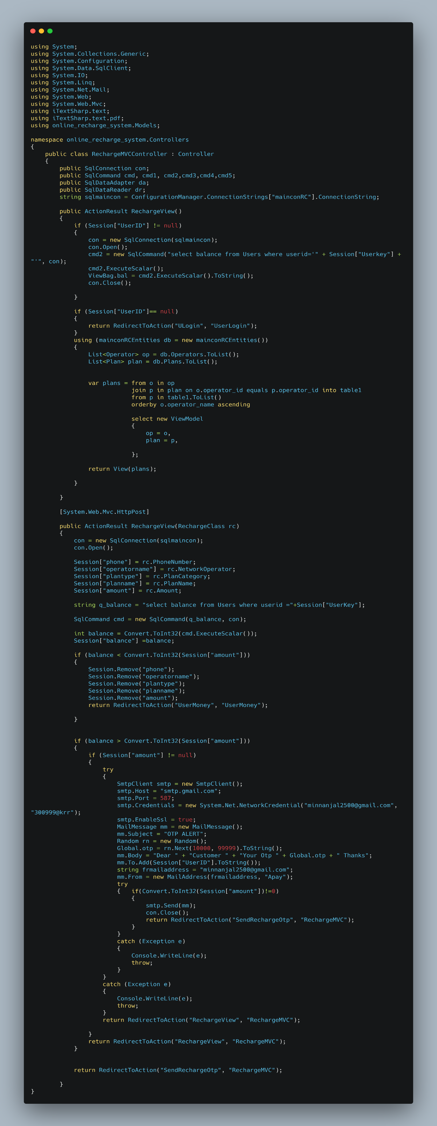

**Recharge : contd..**

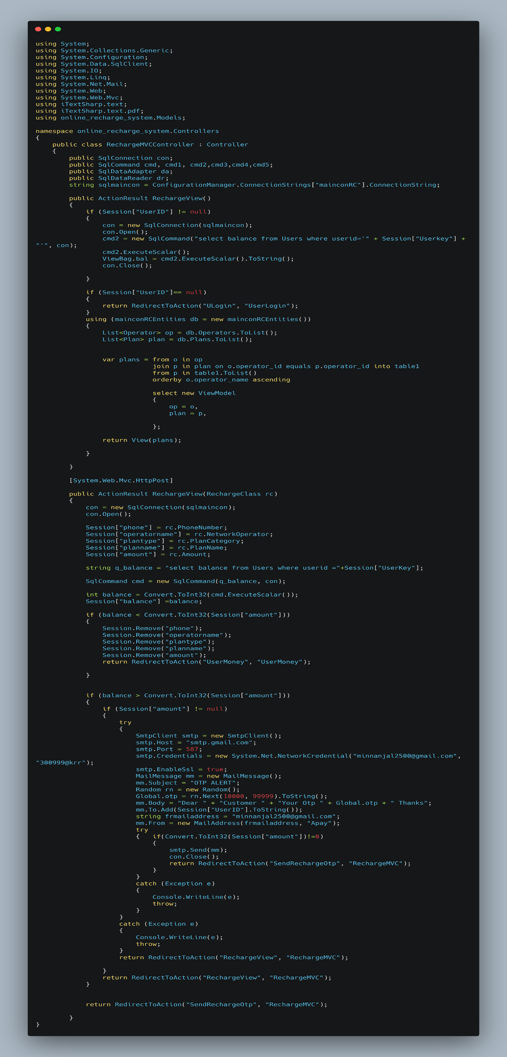

**Send OTP Recharge:**

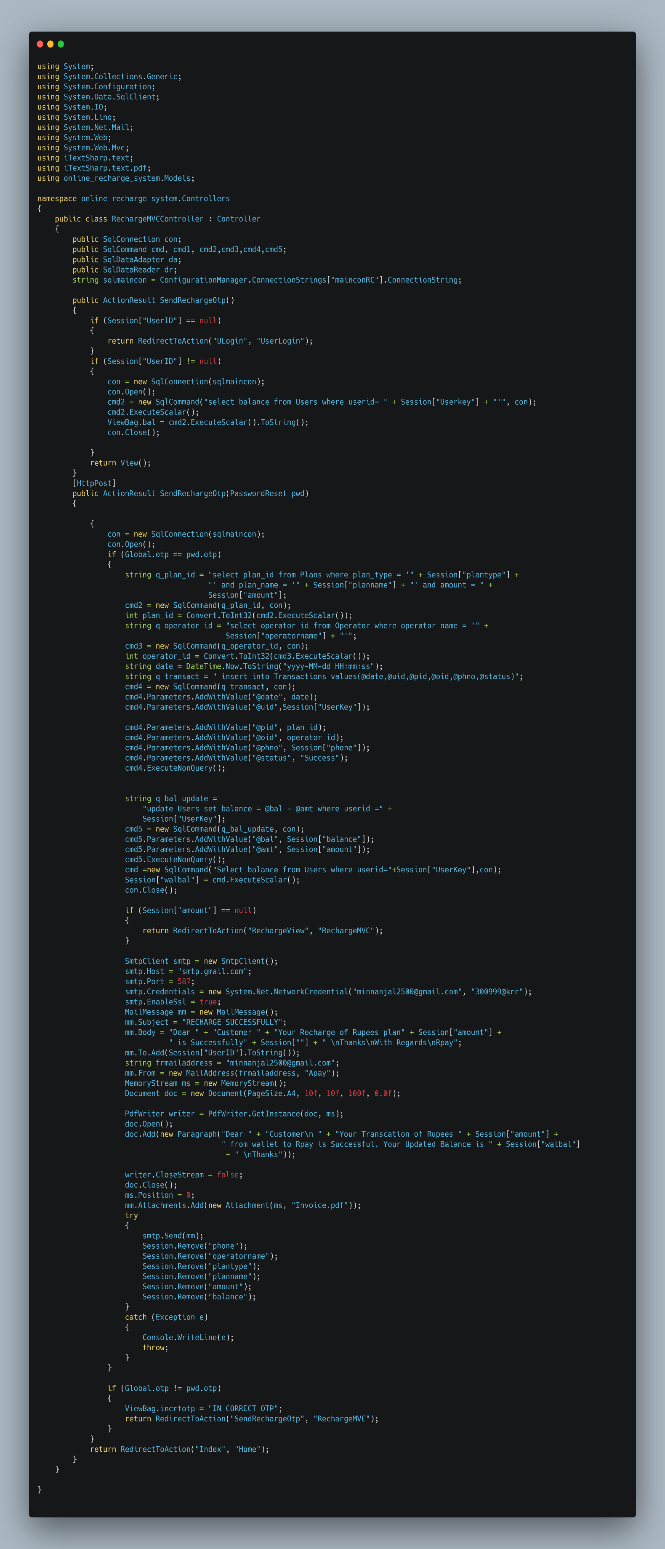

**Send OTP Recharge: contd.**

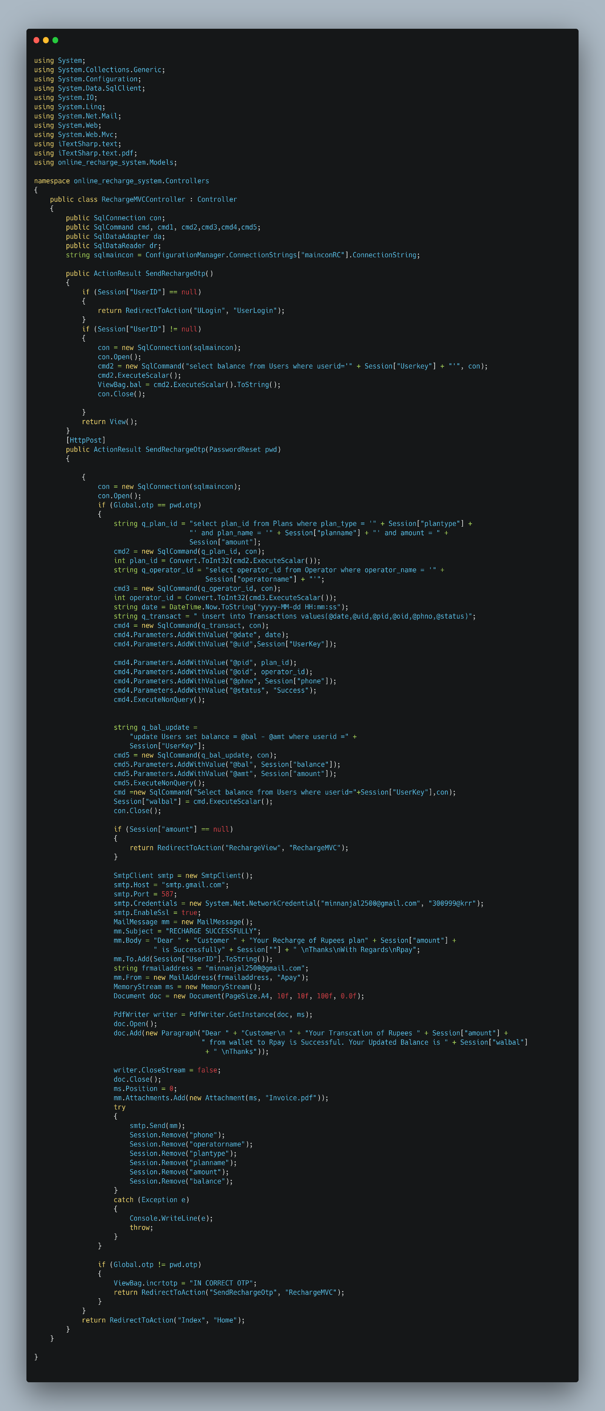

**Email OTP Generation:**

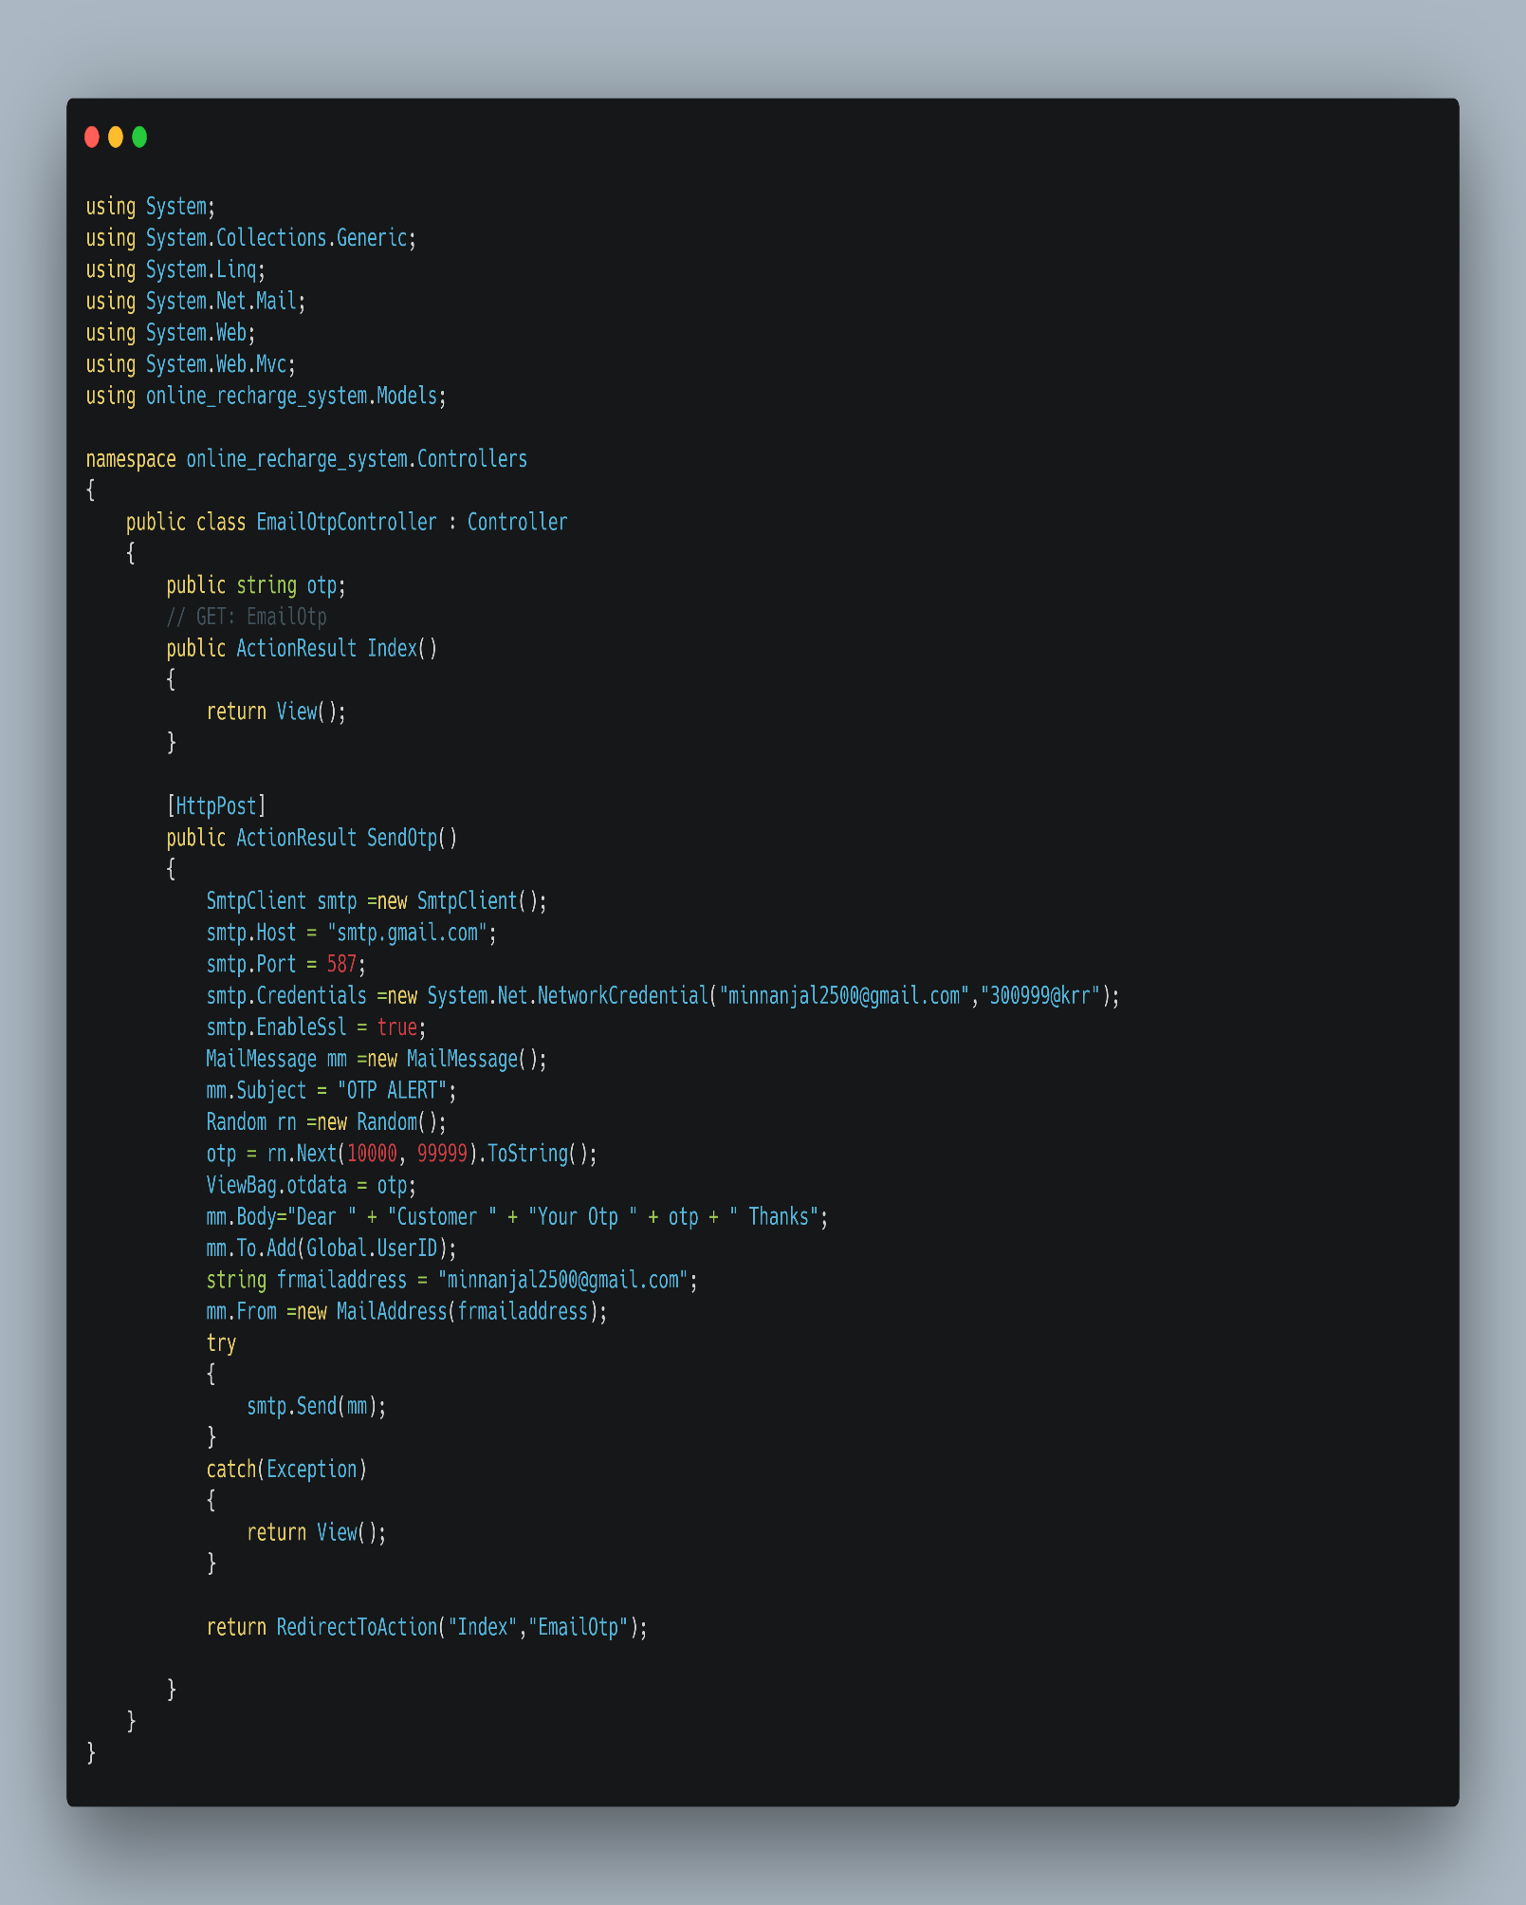

**Add Money to Wallet:**

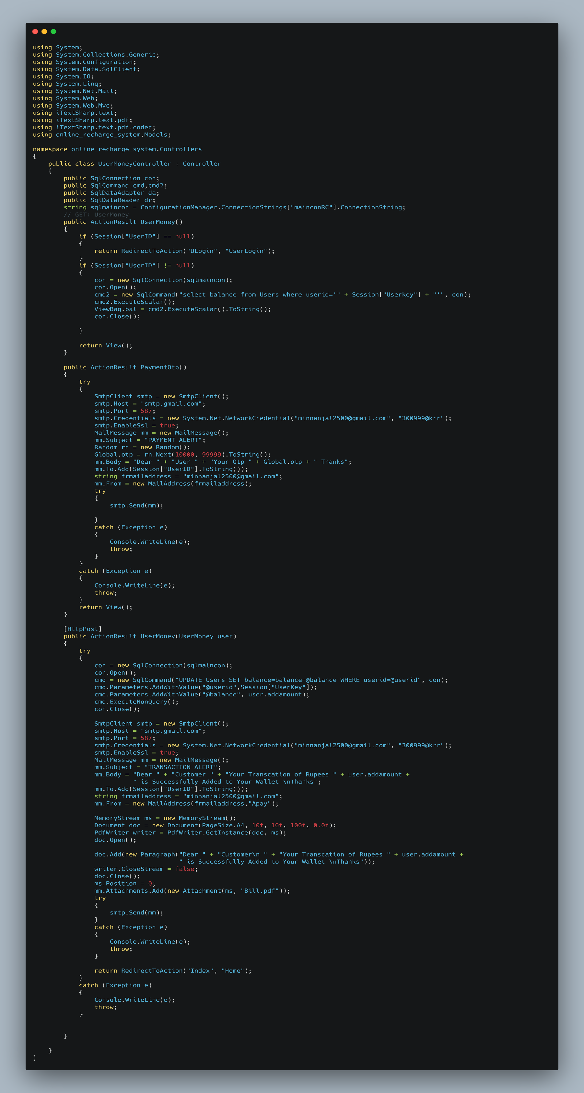

**Add money to Wallet: contd**

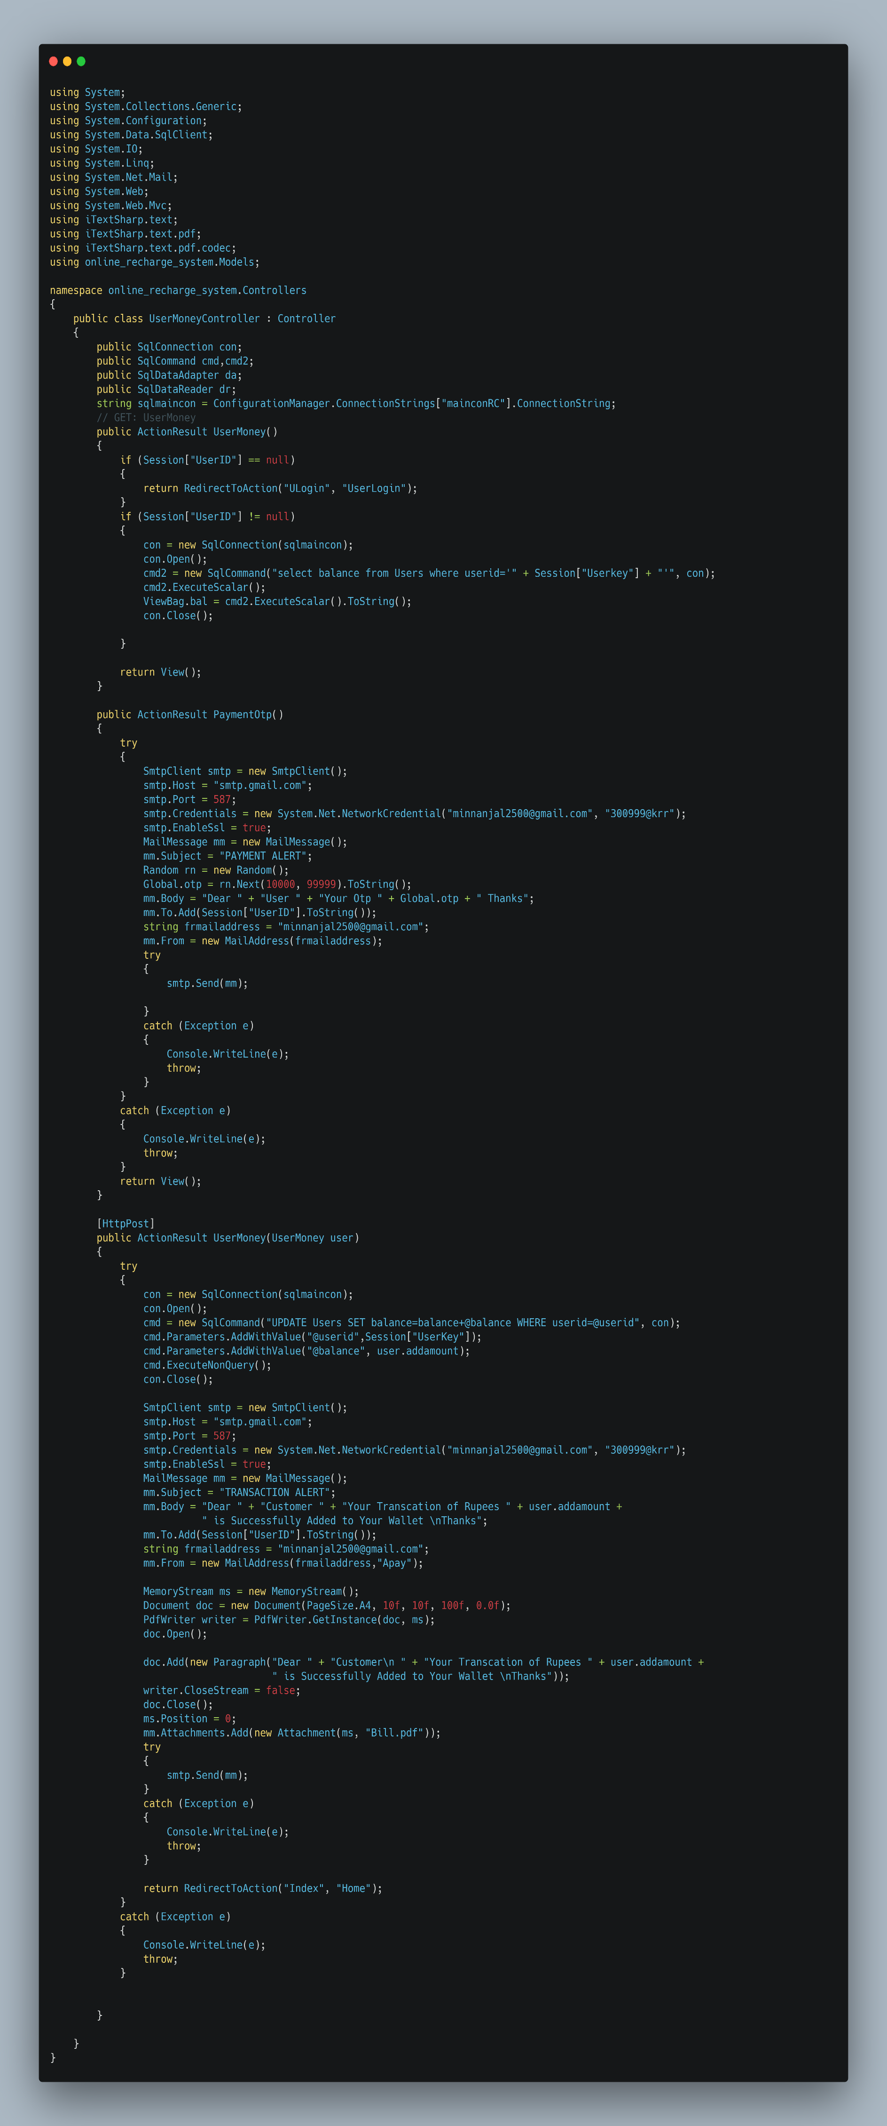

**My Plans:**

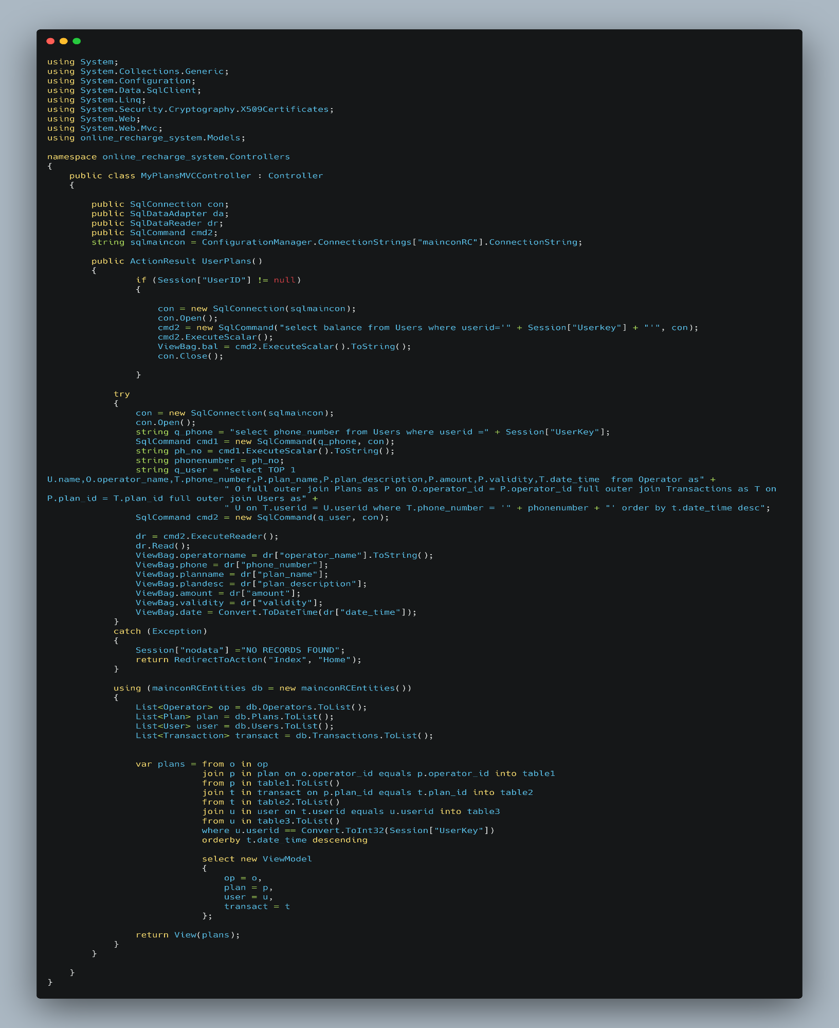

**PROJECT OUTPUT SCREENSHOTS**

**SCREENSHOT 1.1:** Home

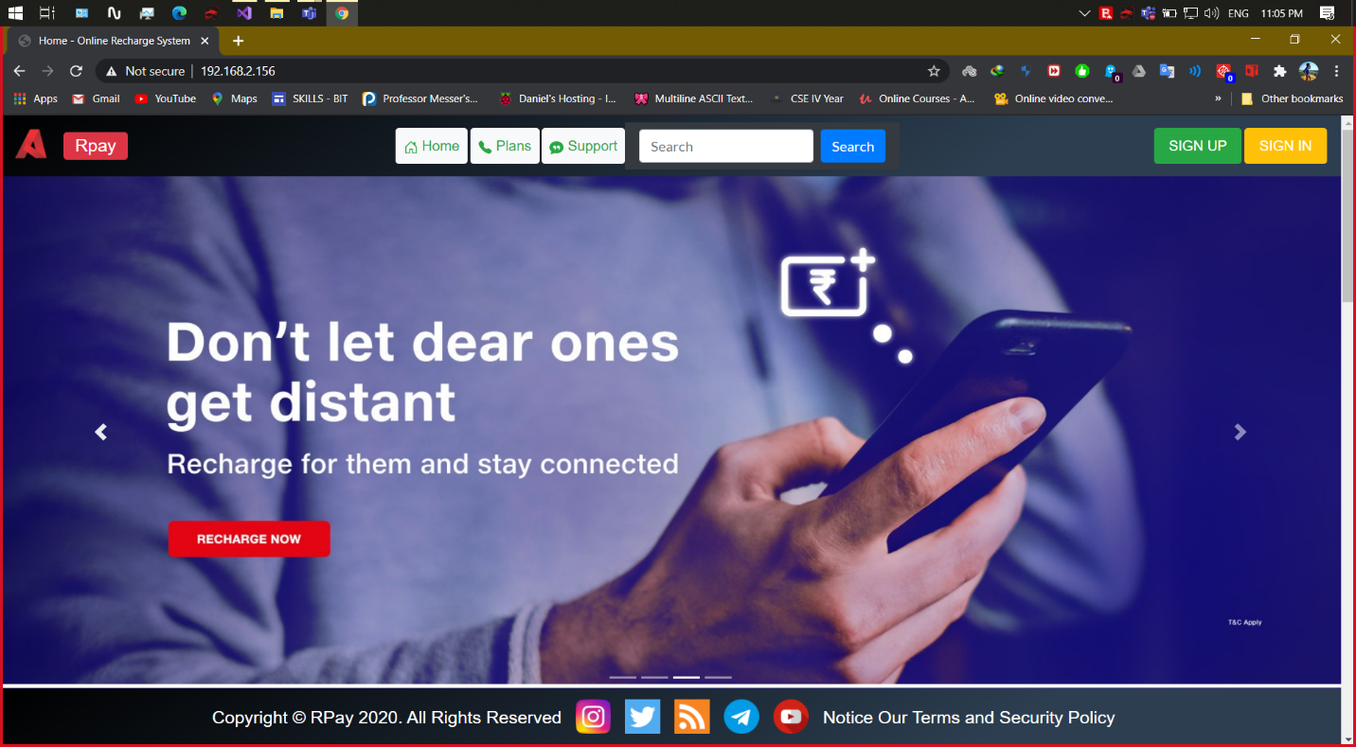

**SCREENSHOT 1.2:** Home (Our Network Partners)

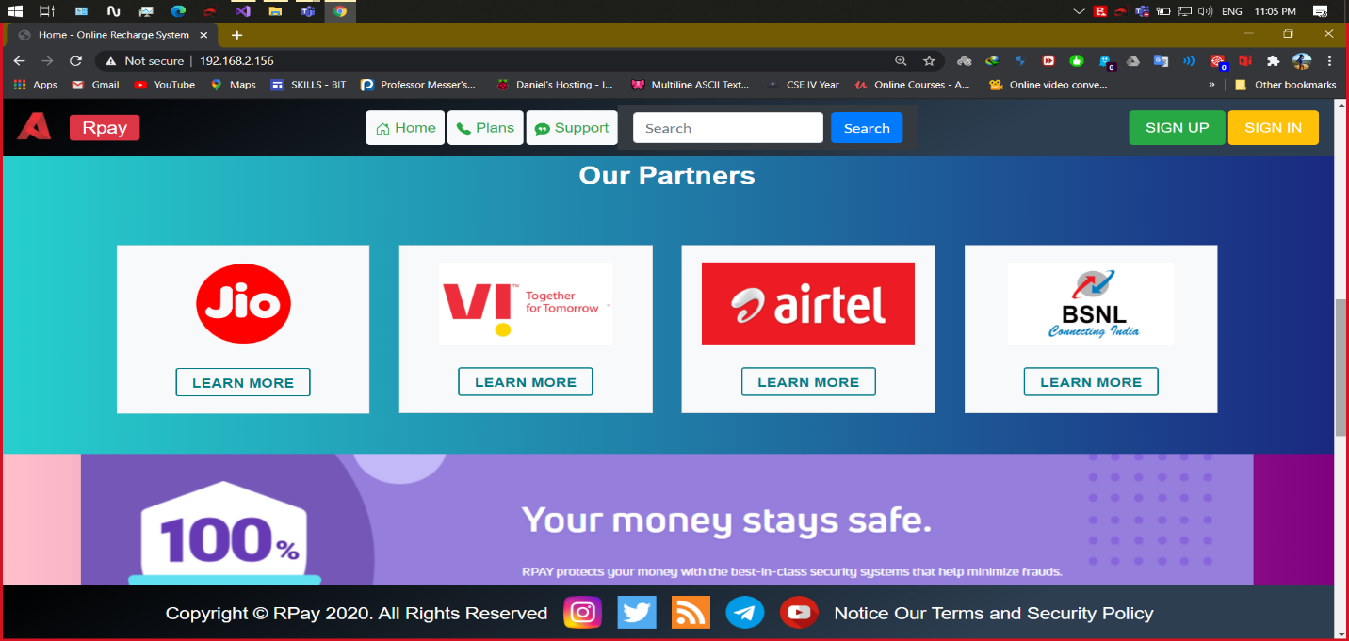

**SCREENSHOT 1.3:** Home (Our Team)

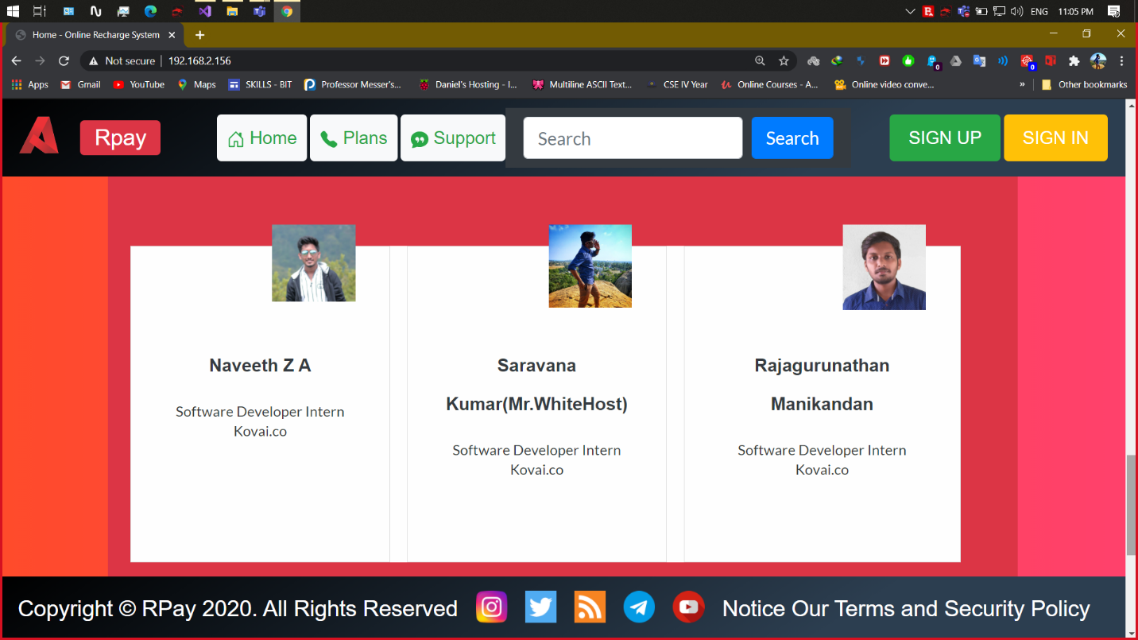

**SCREENSHOT 1.4:** Home (Recharge Plans)

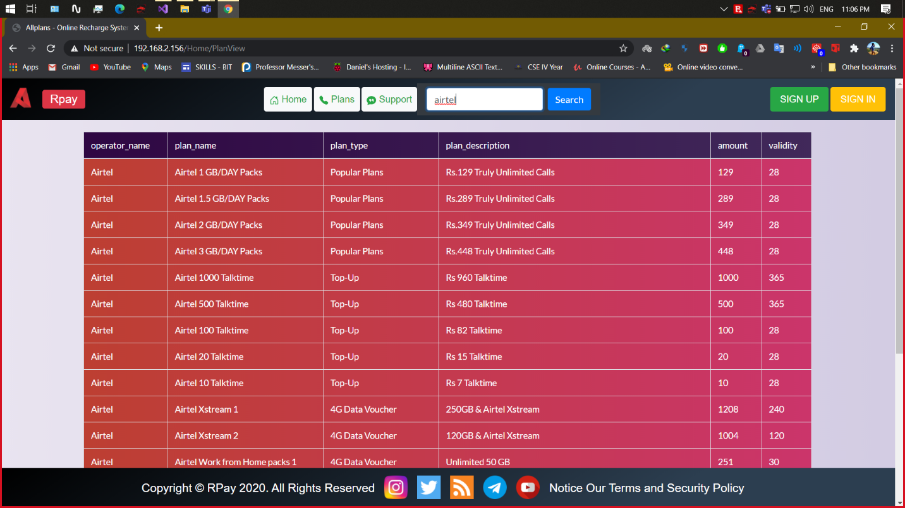

**SCREENSHOT 2.1:** User Signup

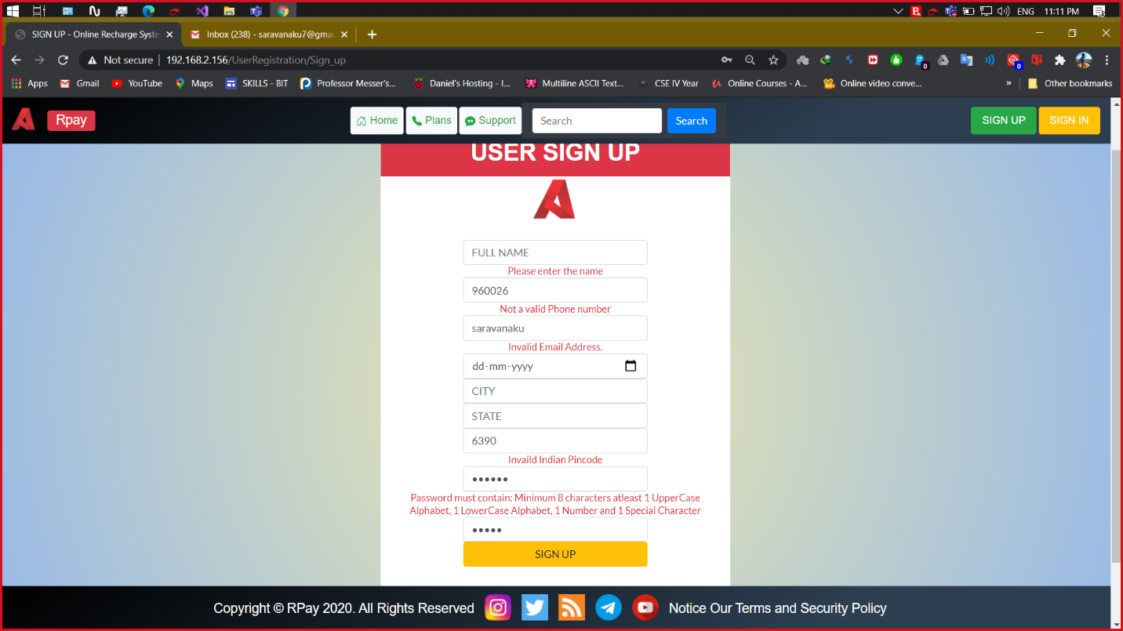

**SCREENSHOT 2.2:** User Signup – Account creation successful mail

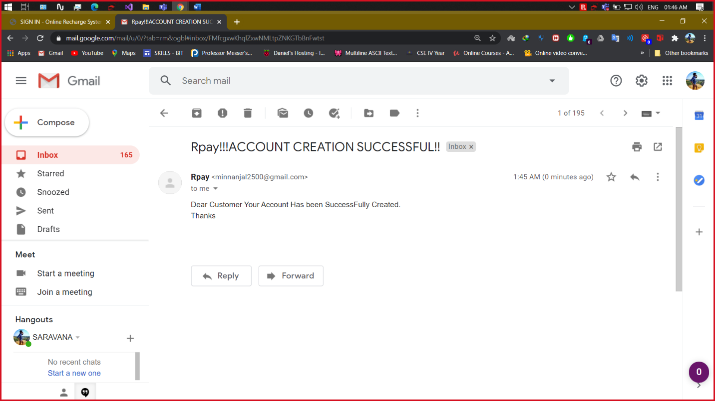

**SCREENSHOT 3:** User SignIn

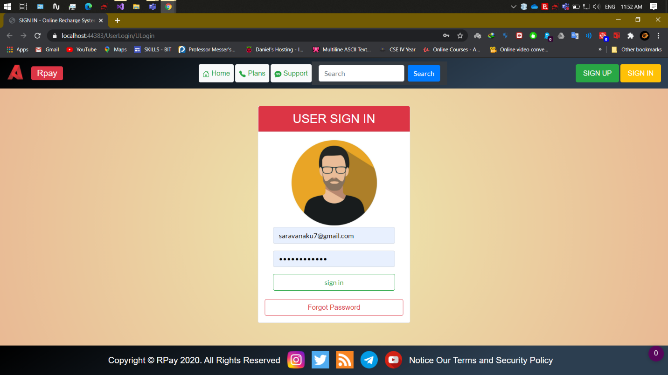

**SCREENSHOT 4:** UserHome

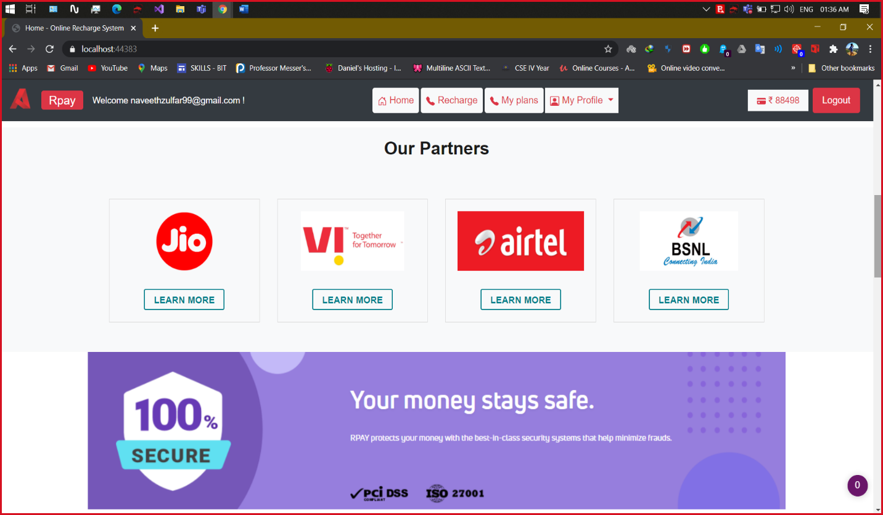

**SCREENSHOT 5.1:** Recharge

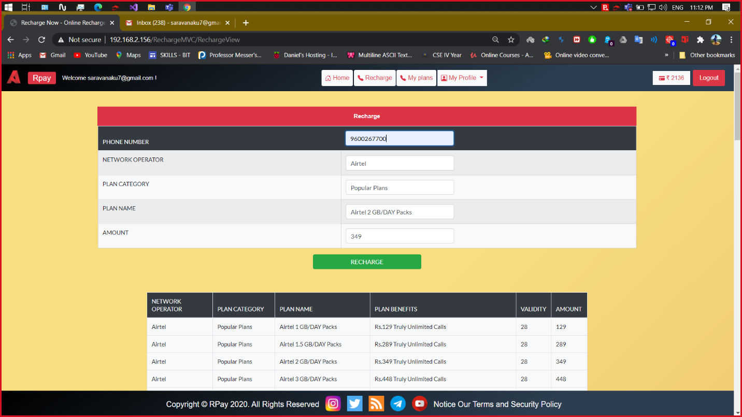

**SCREENSHOT 5.2:** Recharge Plans

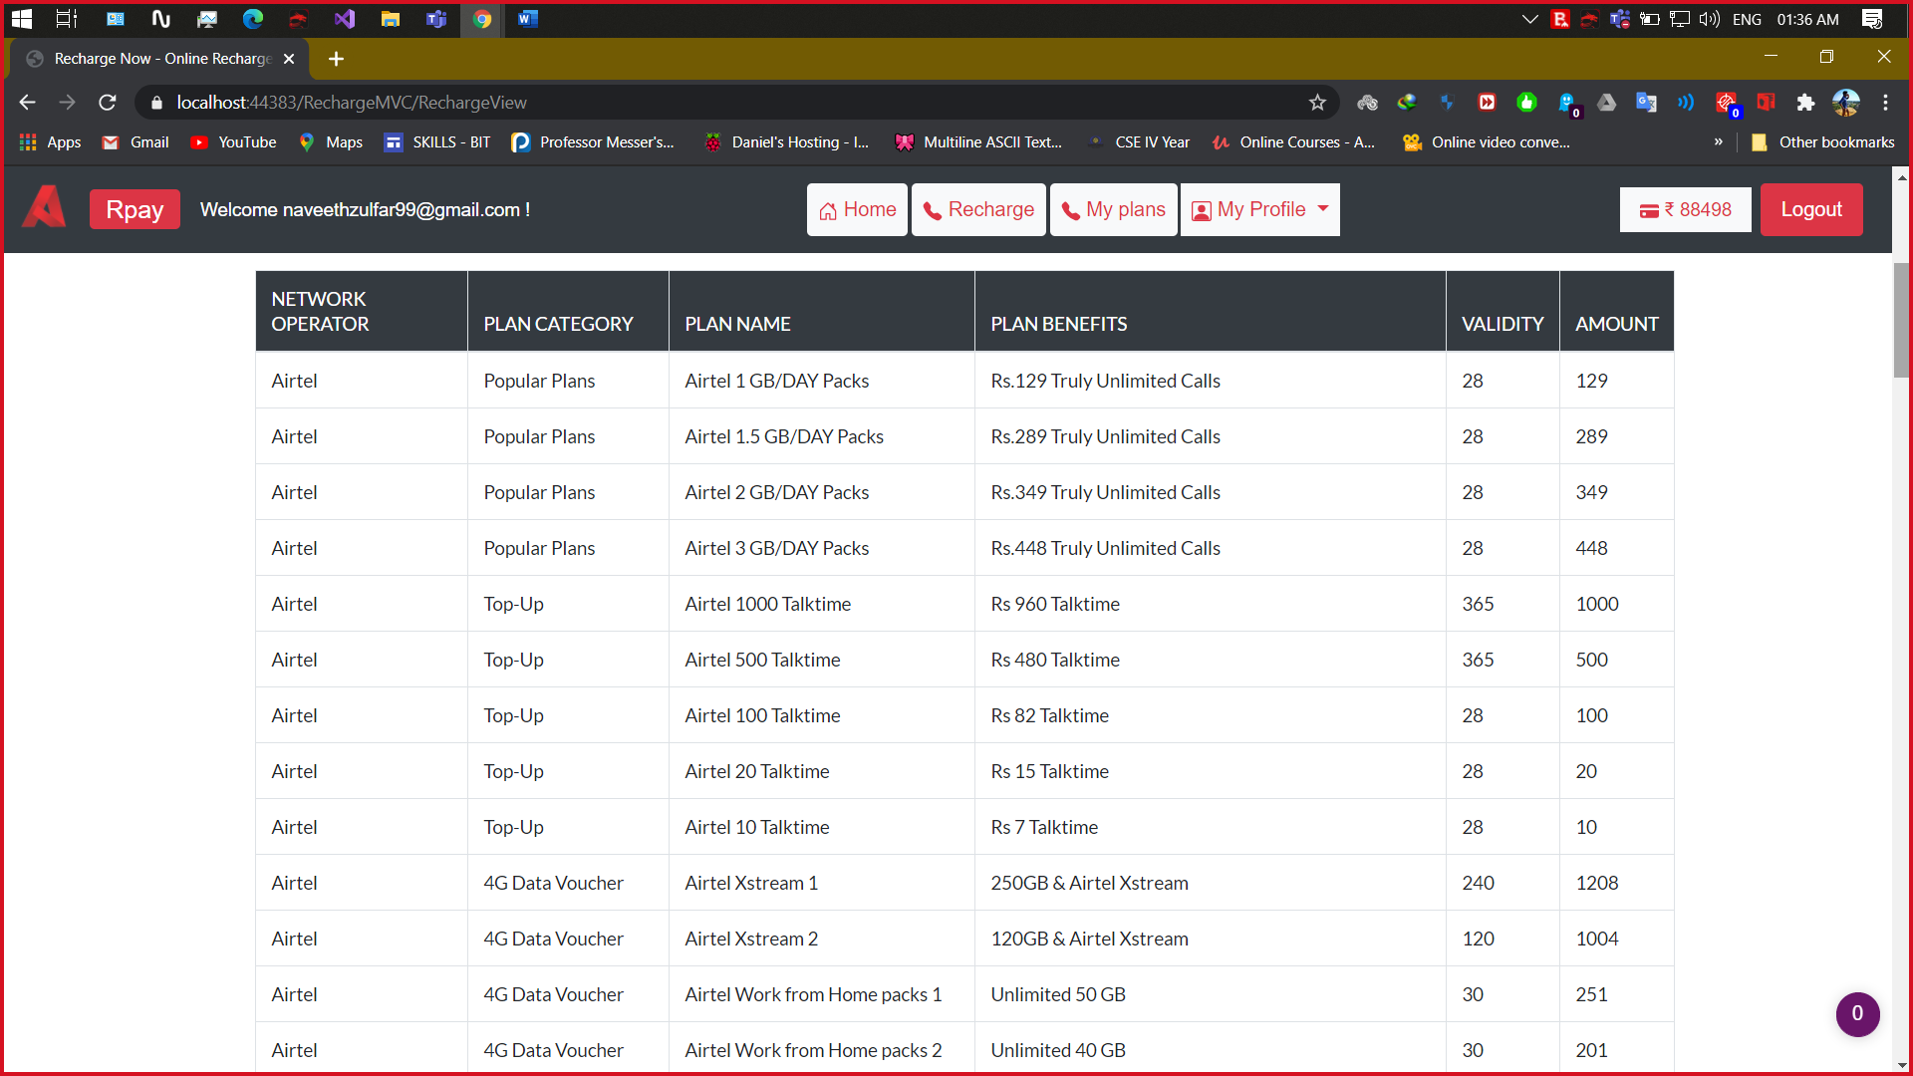

**SCREENSHOT 5.3:** Recharge OTP Alert Mail

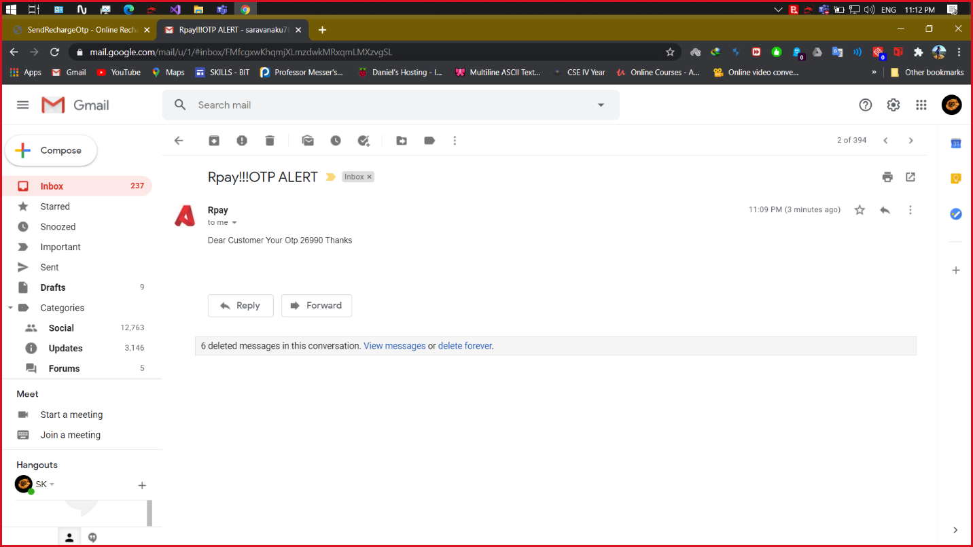

**SCREENSHOT 5.4:** Recharge OTP

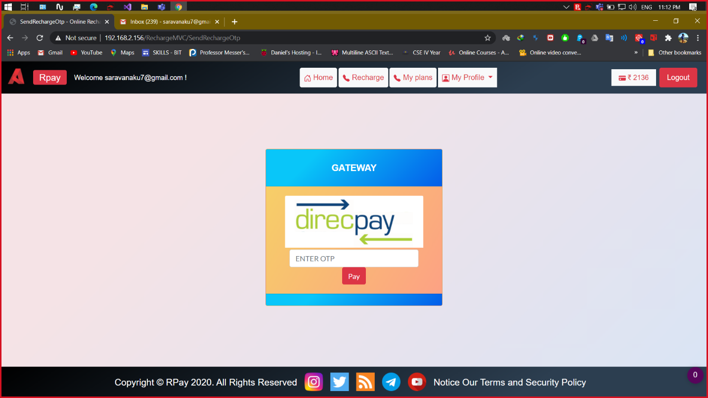

**SCREENSHOT 5.5:** Recharge Mail Confirmation

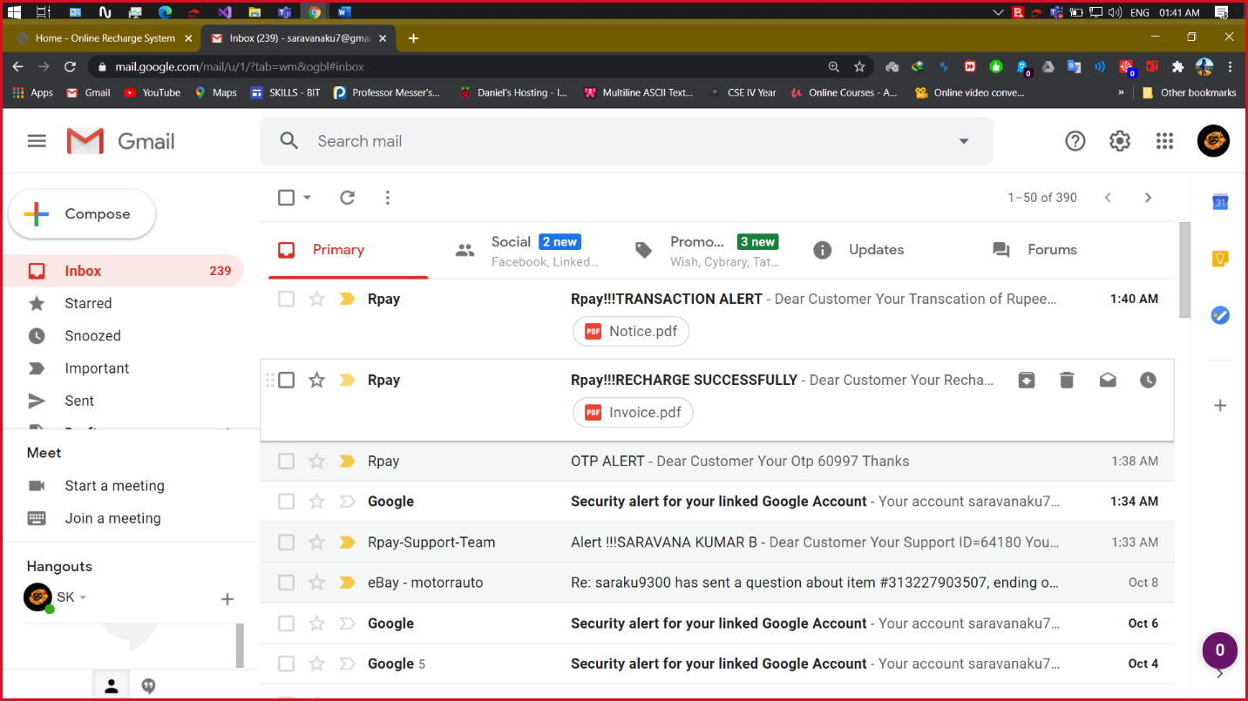

**SCREENSHOT 5.6:** Home Recharge success Mail

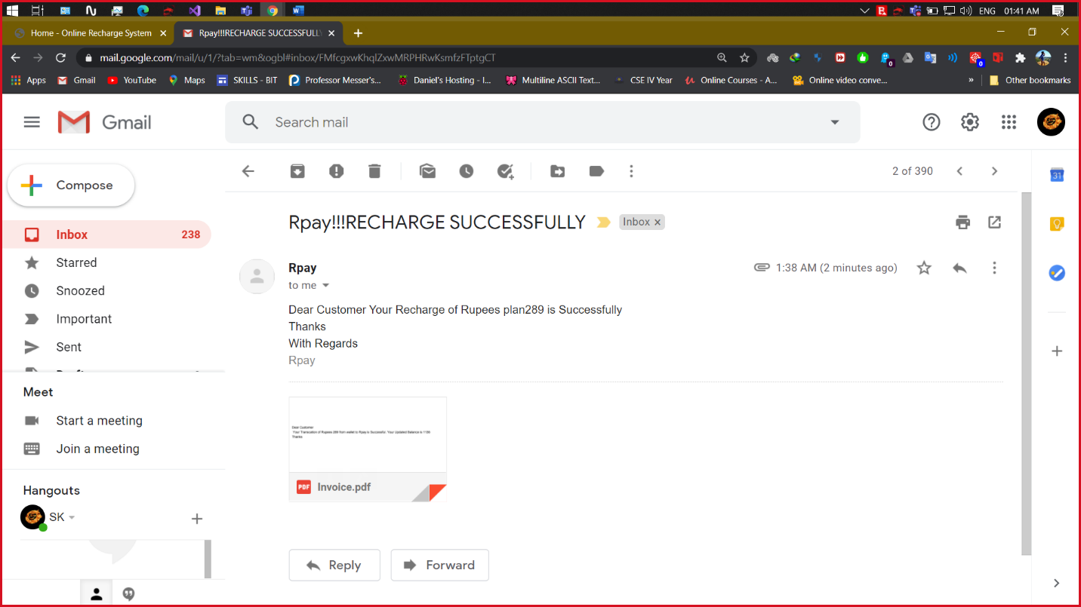

**SCREENSHOT 5.7:** Recharge Mail Invoice

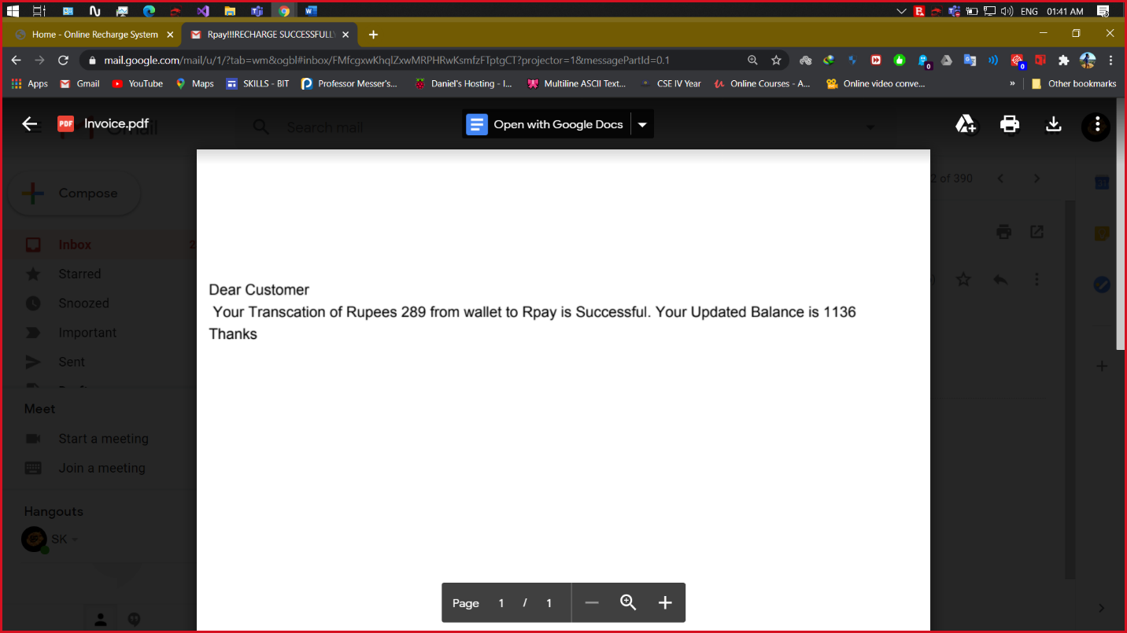

**SCREENSHOT 6:** My Plans

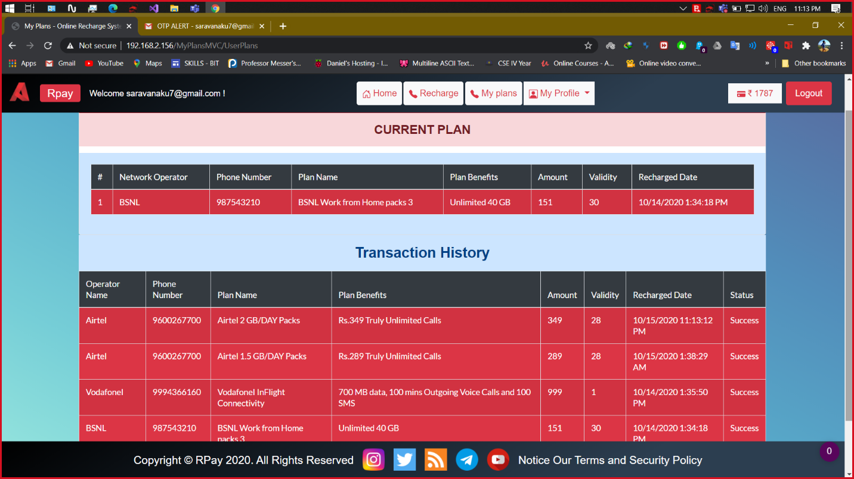

**SCREENSHOT 7.1:** Add Money to Wallet

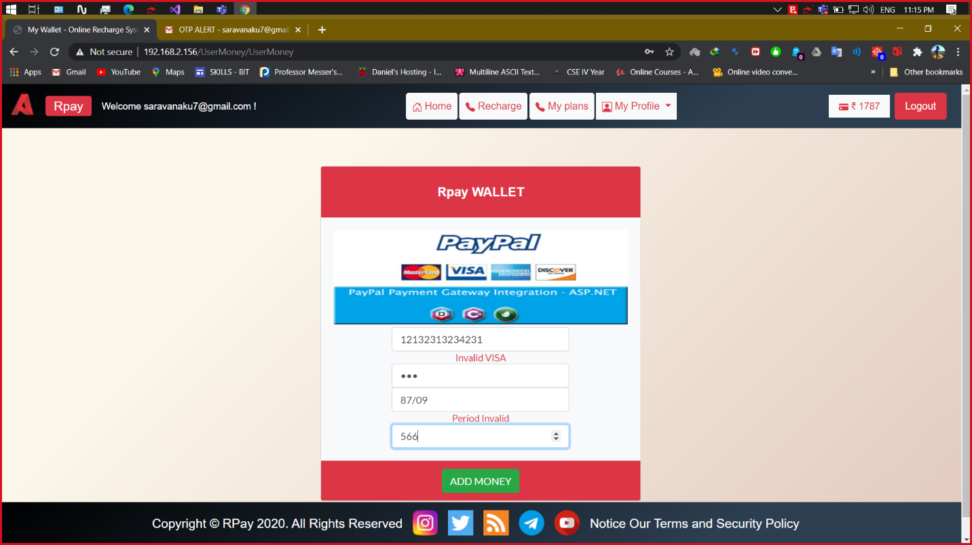

**SCREENSHOT 7.2:** Add Money to Wallet – mail alert

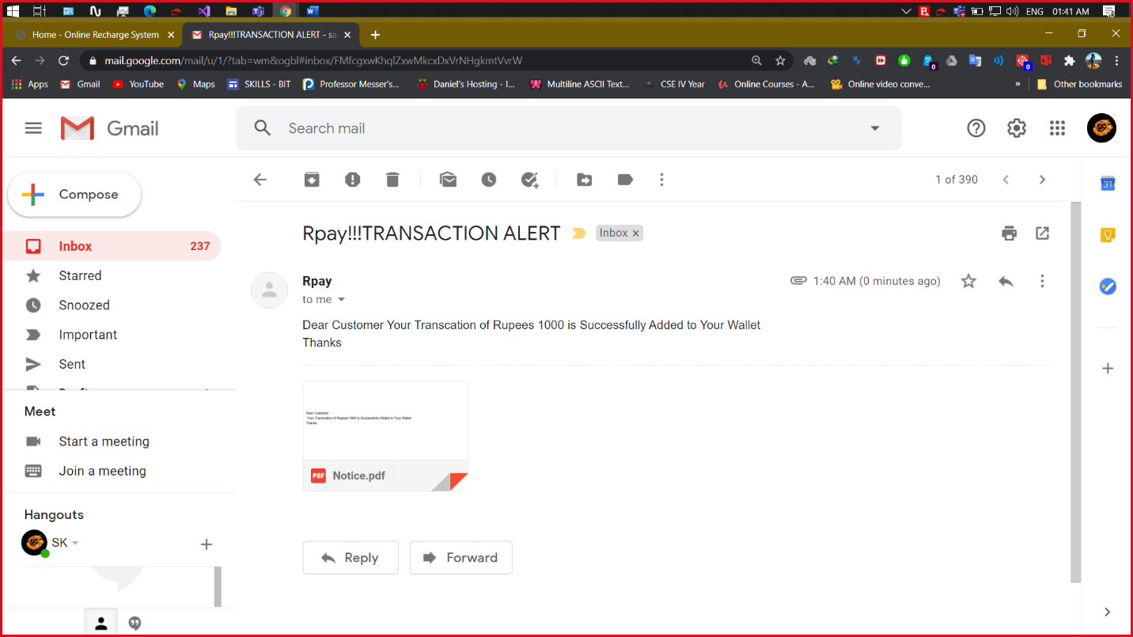

**SCREENSHOT 7.3:** Add Money to Wallet - mail invoice

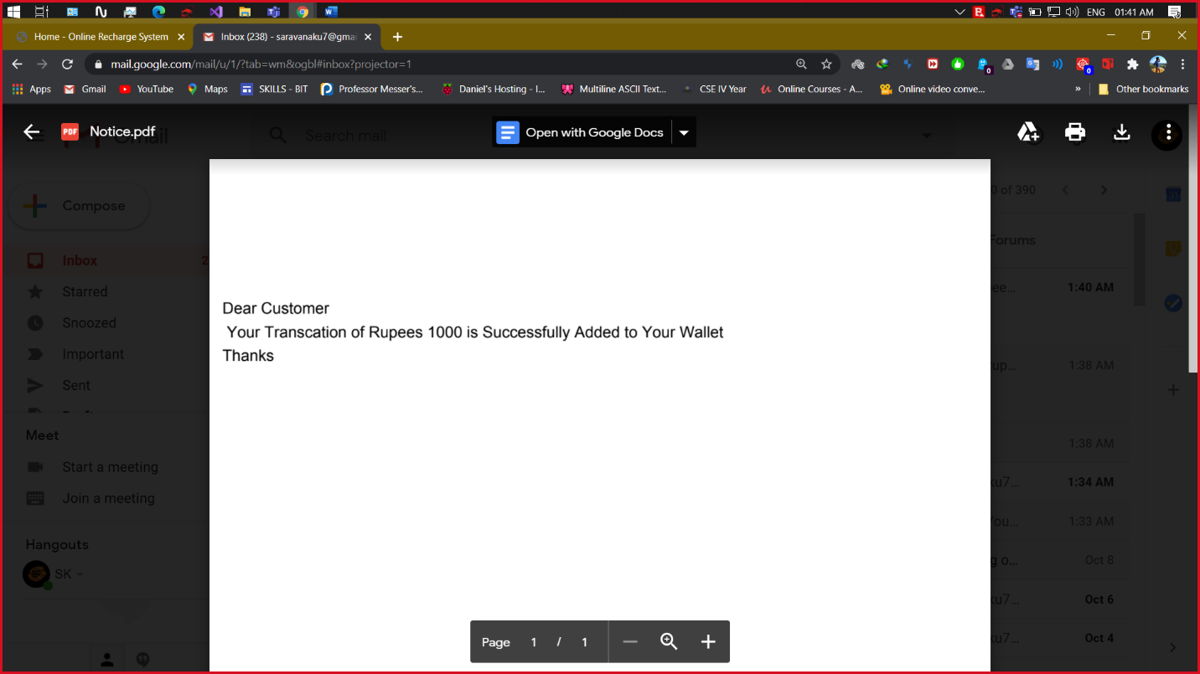

**SCREENSHOT 8:** User Edit Profile

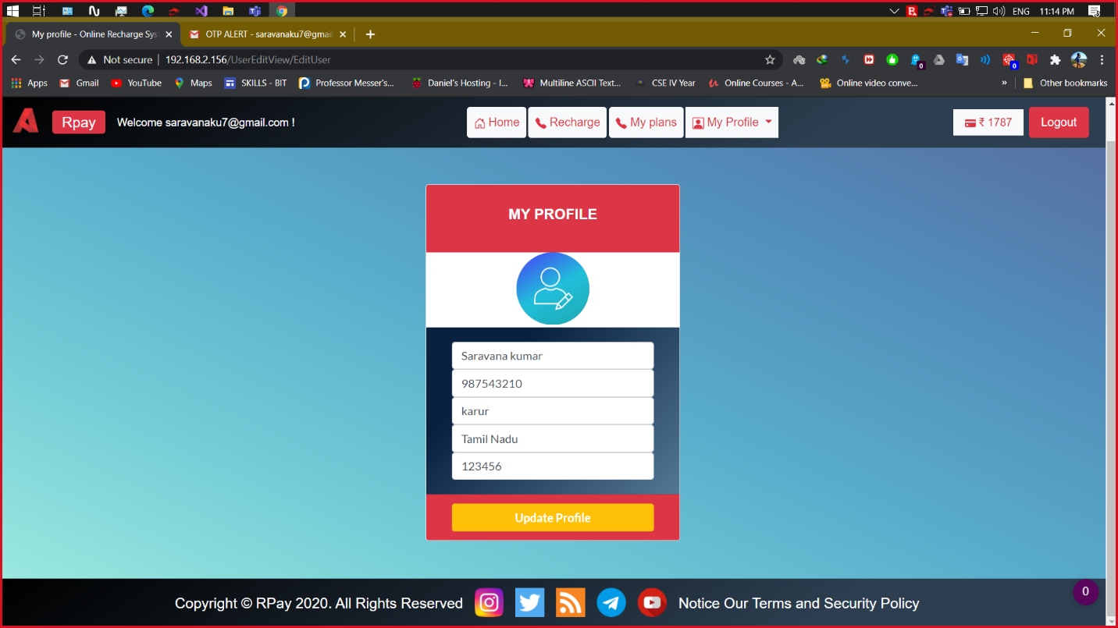

**SCREENSHOT 9:** Admin Login

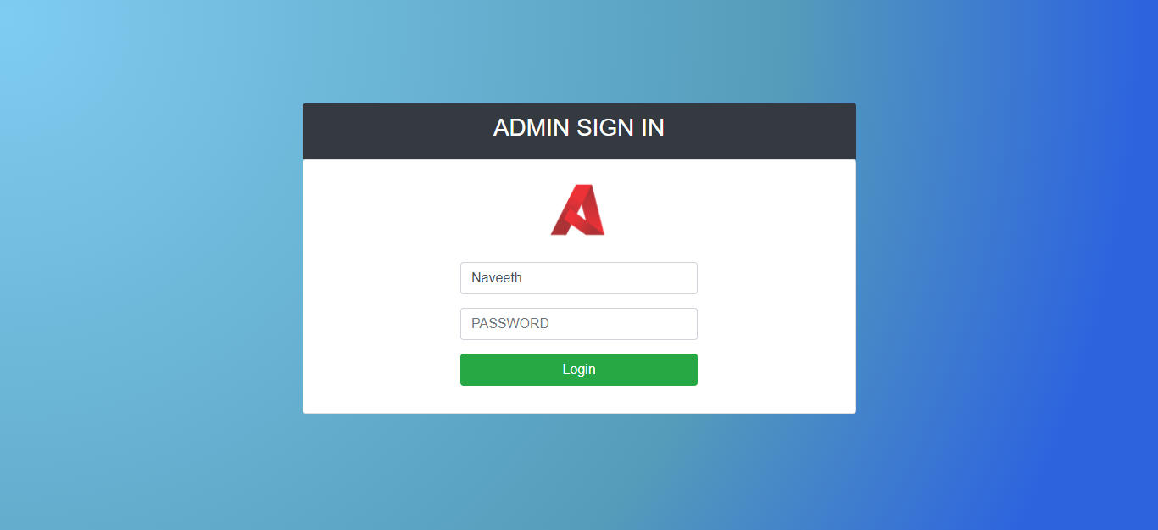

**SCREENSHOT 10:** Admin Dashboard

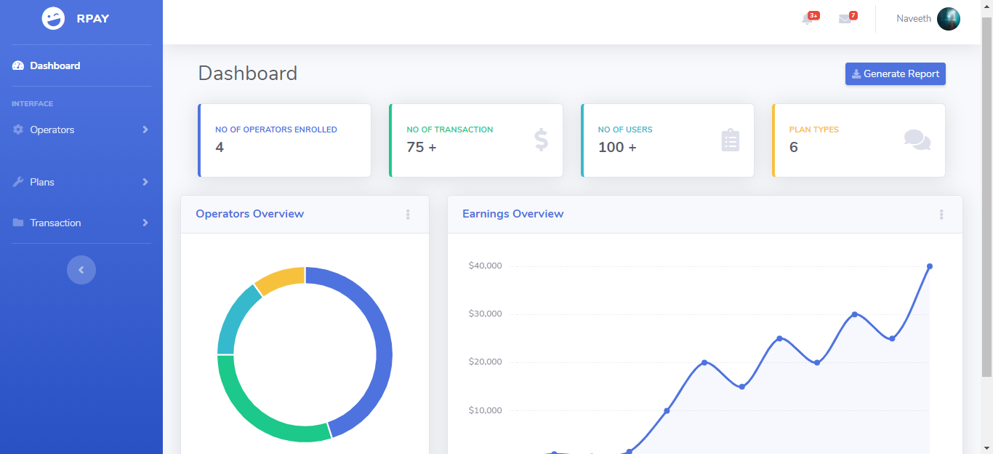

**SCREENSHOT 11:** Network Operator Manager

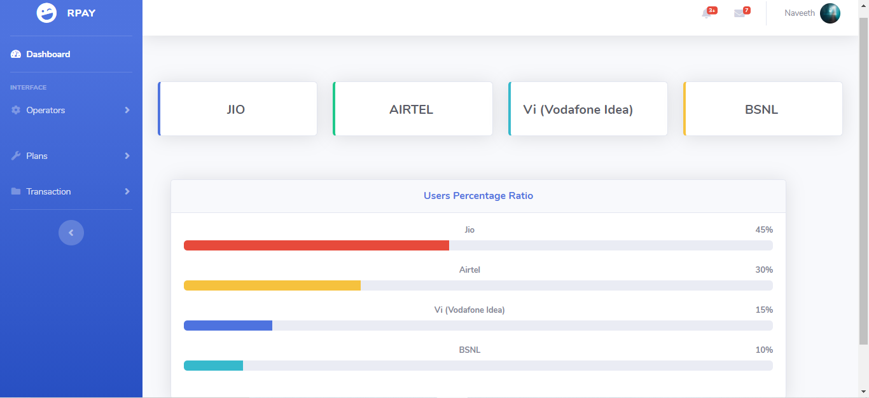

**SCREENSHOT 12:** Recharge Plans Manager

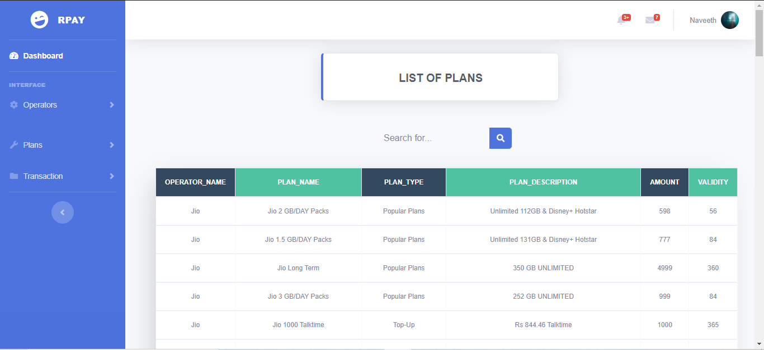

**SCREENSHOT 13.1:** Recharge Transactions Manager

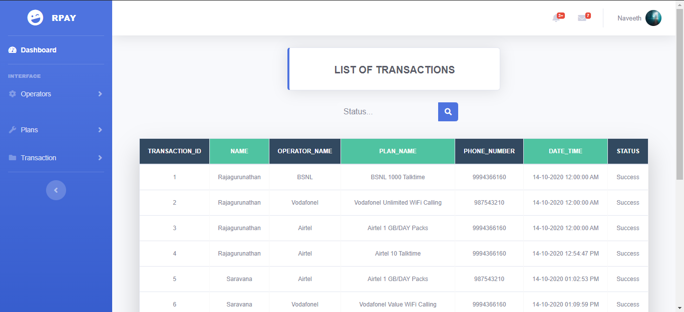

**SCREENSHOT 13.2:** Recharge Transactions PDF Generation

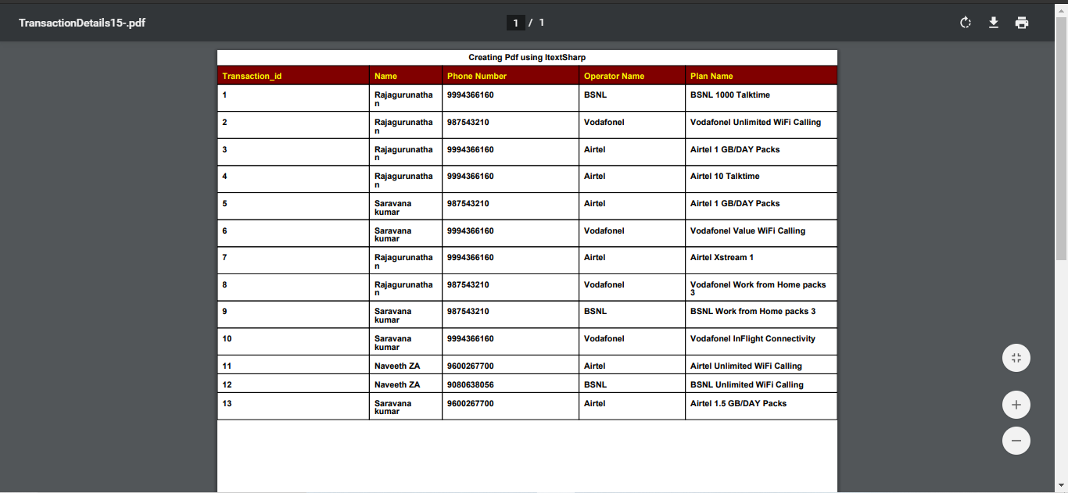

**SCREENSHOT 14.1:** Customer Support

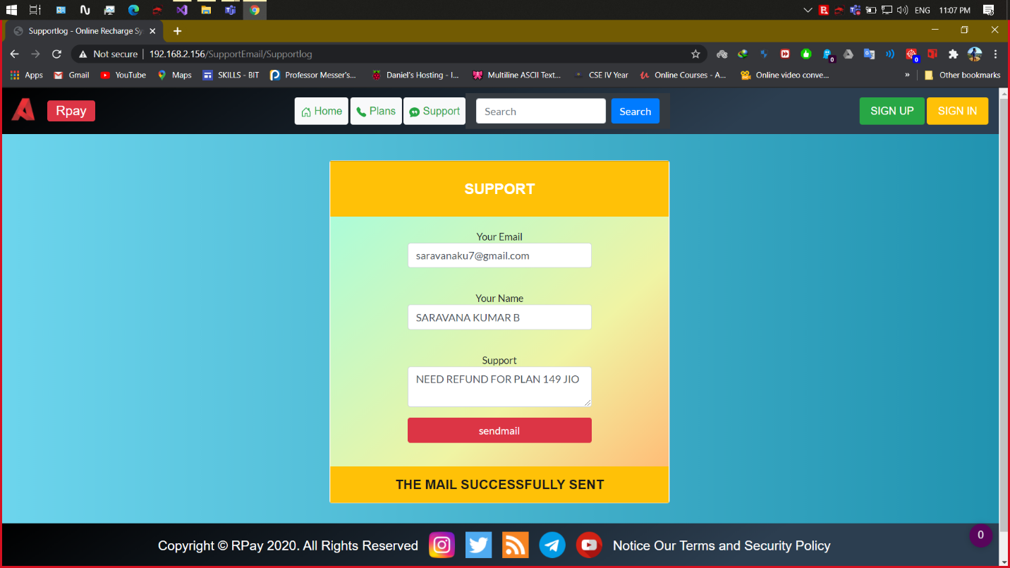

**SCREENSHOT 14.2:** Customer Support Mail

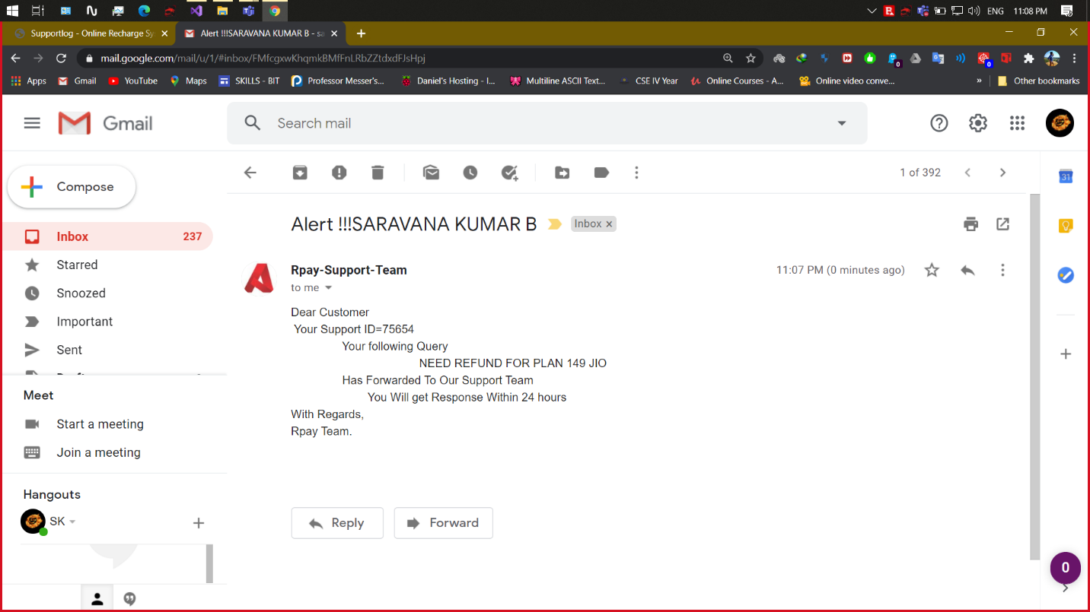

**SCREENSHOT 15.1:** Forgot Password (Send OTP)

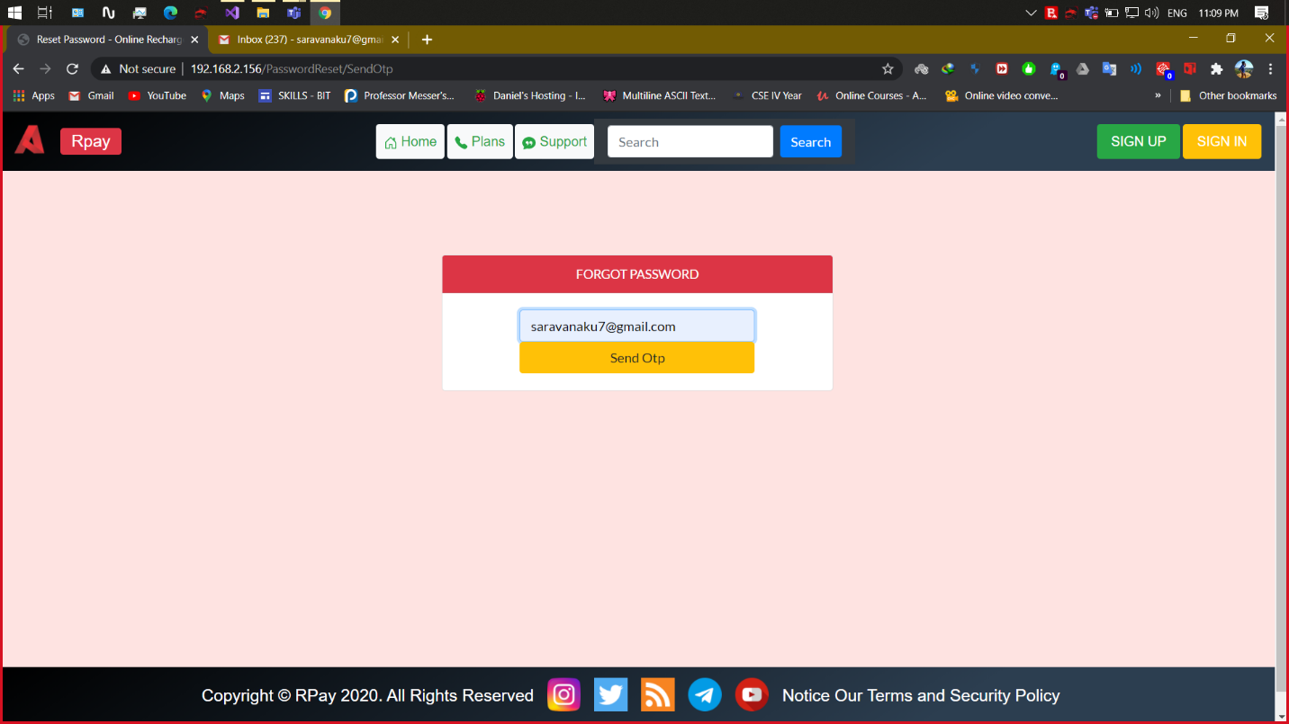

**SCREENSHOT 15.2:** Forgot Password (New Password)

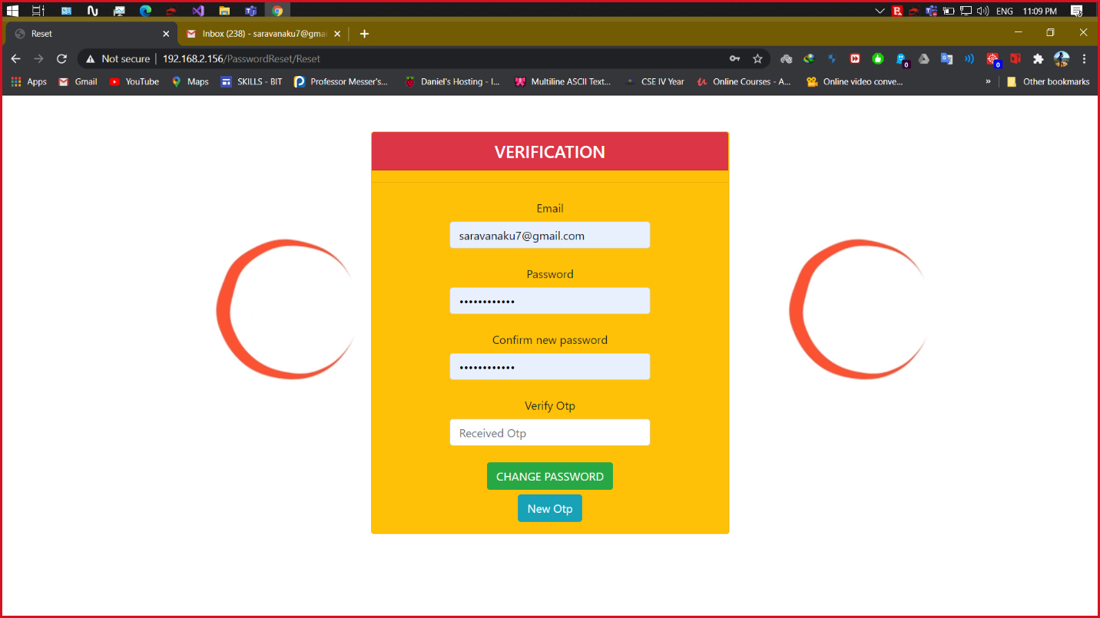

**ROLES AND RESPONSIBILITIES**

**SCREENSHOT WISE:**

|  |  |  |  |
| --- | --- | --- | --- |
| **Screenshot No** | **Page Name** | **Frontend** | **Backend** |
| 1 | Home | Naveeth, Saravanakumar | Saravanakumar |
| 2 | User Signup | Naveeth, Saravanakumar | Saravanakumar |
| 3 | User Login | Saravanakumar | Rajagurunathan,  Saravanakumar |
| 4 | User Home | Naveeth, Saravanakumar | Saravanakumar |
| 5 | Recharge | Rajagurunathan | Rajagurunathan, Saravanakumar |
| 6 | My Plans | Rajagurunathan | Rajagurunathan |
| 7 | Add Money to wallet | Saravanakumar | Saravanakumar |
| 8 | User Edit Profile | Rajagurunathan | Rajagurunathan |
| 9 | Admin Login | Rajagurunathan | Rajagurunathan |
| 10 | Admin Dashboard | Naveeth | Naveeth |
| 11 | Network Operator Manager | Naveeth | Naveeth |
| 12 | Recharge Plans Manager | Naveeth | Naveeth |
| 13 | Recharge Transaction Manager | Rajagurunathan | Naveeth |
| 14 | Customer Support | Rajagurunathan | Saravanakumar |
| 15 | Forgot Password | Saravanakumar | Saravanakumar |
|  | Database Management | Rajagurunathan | |

**MODULE WISE:**

**1) Member Name: Naveeth Z A (Team Leader)**

* Home - Front End
* User Signup - Front End
* User Home - Front End
* Admin Login - Front End & Back End
* Student Profile - Front End & Back End
* Admin Dashboard - Front End & Back End
* Network Operator Manager- Front End & Back End
* Recharge Plans Manager - Front End & Back End
* Recharge Transactions Manager - Back End
* Integration

**2) Member Name: Rajagurunathan Manikandan**

* Database Creation & Management
* Query Management
* My Plans – Front End & Back End
* Recharge - Front End & Back End
* Edit Profile – Front End & Back End
* User Login – Back End
* Customer Support – Front End
* Admin Login - Front End & Back End
* Recharge Transaction Manager – Front End
* Integration
* Dry Run

**3) Member Name: Saravanakumar Balasubramaniyam**

* Home – Front End & Back End
* User Signup– Front End & Back End
* User Login – Front End & Back End
* User Home– Front End &Back End
* Recharge – Back End (Email API Authentication -SMTP)
* Add Money to Wallet- Front End & Back End
* Customer Support – Back End
* Forgot Password - Front End &Back End
* Integration
* Session Management
* Online Database Hosting
* Web Hosting

**PROJECT SOURCE CODE LINK**

**Onedrive:**

[**https://kovailtd-my.sharepoint.com/:f:/g/personal/syed_haroon_kovai_co/ElYOyjneyfNKu3-4wZGwAwUBInH8YMoGF1Me1nmHRXTLOg?e=hlid6n**](https://kovailtd-my.sharepoint.com/:f:/g/personal/syed_haroon_kovai_co/ElYOyjneyfNKu3-4wZGwAwUBInH8YMoGF1Me1nmHRXTLOg?e=hlid6n)